

Project Plan
For [Project Name]

Document Control

Document Information
© | Information
Document Id | [Document Management System #]
Document Owner | [Owner Name]
Issue Date | [Date]
Last Saved Date | [Date]
File Name | [Name]

Document History
Version | Issue Date | Changes
[1.0] | [Date] | [Section, Page(s) and Text Revised]

Document Approvals
Role | Name | Signature© | Date
Project Sponsor

Project Review Group

Project Manager

Quality Manager
(if applicable)

Procurement Manager
(if applicable)

Communications Manager
(if applicable)

Project Office Manager
(if applicable)

Table of Contents

Template Guide 1
1 Planning Basis 2
1.1 Scope 2
1.2 Milestones 2
1.3 Phases 2
1.4 Activities 3
1.5 Tasks 3
1.6 Effort 3
1.7 Resources 4
2 Project Plan 4
2.1 Schedule 4
2.2 Dependencies 5
2.3 Assumptions 5
2.4 Constraints 5
3 Appendix 5

Template Guide

What is a Project Plan?

The Project Plan is the central document by which the project is formally managed. A Project Plan is a document which lists the activities, tasks and resources required to complete the project and realise the business benefits outlined in the Project Business Case. A typical Project Plan includes:

- A description of the major phases undertaken to complete the project
- A schedule of the activities, tasks, durations, dependencies, resources and timeframes
- A listing of the assumptions and constraints identified during the planning process.

To create a Project Plan, the following steps are undertaken:

- Reiterate the project scope
- Identify the project milestones, phases, activities and tasks
- Quantify the effort required for each task
- Allocate project resource
- Construct a project schedule
- List any planning dependencies, assumptions, constraints
- Document the formal Project Plan for approval.

When to use a Project Plan

Although a summarised Project Plan is identified early in the Project Start-up Phase (within the Business Case), a detailed Project Plan is not usually created until the project scope has been formally defined (within a Project Charter) and the project team appointed. The Project Plan is completed early in the Project Planning Phase and is, typically, prior to a Quality Plan and the formalisation of a Supplier's contract. Unlike other documents in the Project Lifecycle, the Project Plan is referenced constantly throughout the project. As the project is undertaken, the Project Manager tracks the percentage of task completion and the task completion date (actual vs planned) to assess overall project performance. These statistics are communicated to the Project Sponsor/Board within a regular Project Status Report.

How to use this template

This document provides a guide on the topics usually included in a Project Plan. Sections may be added, removed or redefined at your leisure to meet your particular business circumstance. Example tables, diagrams and charts have been added (where suitable) to provide further guidance on how to complete each relevant section.

Planning Basis

Scope
The activities and tasks defined in the project plan must be undertaken within the scope of the project. For this reason, reiterate the scope of the project here as defined in the Project Project Charter.

Milestones
A milestone is “a major event in the project” and represents the completion of a set of activities. Examples of milestones include:

- Business Case approved
- Feasibility Study approved
- Project Charter approved
- Project Team appointed
- Project Office established.

List and describe the key project milestones within the following table:

Milestone | Description | Delivery Date
Business Case Approved. | The Business Case has been documented and was approved by the Project Sponsor. | xx/yy/zz

Phases
A phase is “a set of activities which will be undertaken to deliver a substantial portion of the overall project”. Examples include:

- Project Initiation
- Project Planning
- Project Execution
- Project Closure.

List and describe the major project phases within the following table.

Phase | Description© | Sequence
Project Initiation | Defining the project by developing a business case, feasibility study and Project Charter as well as recruiting the project team and establishing the project office. | Phase # 1

Activities
An activity is “a set of tasks which are required to be undertaken to complete the project." Examples include:

- Develop Quality Plan
- Formulate Supplier Contracts
- Perform Project Closure.

List and describe the major project activities within the following table.

Phase | Activity | Description© | Sequence
Project Planning | Develop Quality Plan | Produce a document describing Quality Assurance and Quality Control and process review activities to be undertaken. | After the Project Plan but before the formulation of supplier contracts

Tasks
A ‘task’ is simply an item of work to be completed within the project. List all tasks required to undertake each activity, within the following table:

Phase | Activity | Task | Sequence
Project Planning | Develop Quality Plan | Identify Quality Targets  Identify Quality Assurance Techniques  Identify Quality Control Techniques  Document Quality Plan | 1st  2nd  3rd  4th

Effort
For each task listed above, quantify the likely ‘effort’ required to complete the task.

Task© | Effort
Identify Quality Targets  Identify Quality Assurance Techniques  Identify Quality Control Techniques  Document Quality Plan | no. days  no. days  no. days  no. days

Resources
For each task identified, list the resources allocated to complete the task.

Task© | Resource
Identify Quality Targets  Identify Quality Assurance Techniques  Identify Quality Control Techniques  Document Quality Plan | name  name  name  name

Project Plan

Schedule
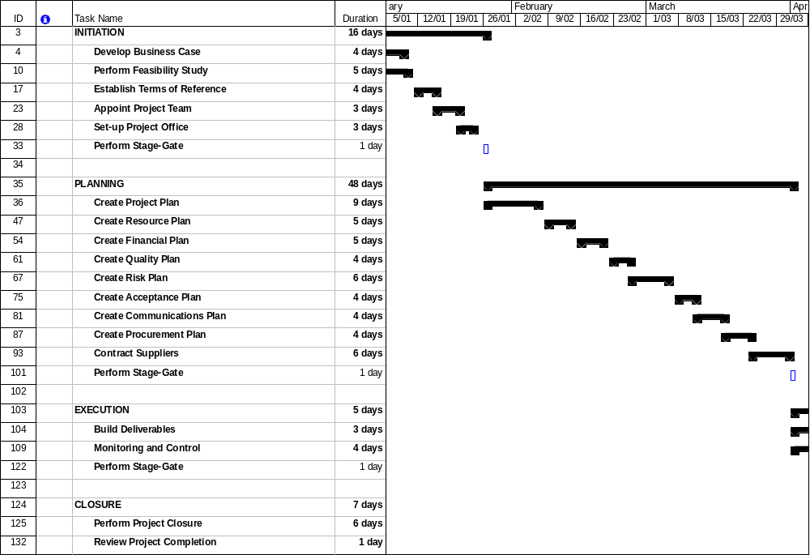
Provide a summarised schedule for each of the phases and activities within the project.

Note: Refer to the Appendix for a detailed project schedule.

Dependencies
‘Dependencies’ are logical relationships between phases, activities or tasks which influence the way that the project must be undertaken. Dependencies may be either internal to the project (e.g. between project activities) or external to the project (e.g. a dependency between a project activity and a business activity). There are four types of dependencies:
- Finish-to-start (the item this activity depends on must finish before this activity can start)
- Finish-to-finish (the item this activity depends on must finish before this activity can finish)
- Start-to-start (the item this activity depends on must start before this activity can start)
- Start-to-finish (the item this activity depends on must start before this activity can finish).

List any key project dependencies identified by completing the following table:

Activity | Depends on© | Dependency Type
Set-up Project Office | Appoint Project Team | Finish-to-start

In the example given above, the activity ”Appoint Project Team” must finish before activity “Set-up Project Office” can start.

Assumptions
List any planning assumptions made. For example:

It is assumed that:
- The project will not change in scope
- The resources identified will be available upon request
- Approved funding will be available upon request.

Constraints
List any planning constraints identified. For example:
- The project must operate within the funding and resource allocations approved
- The project team must deliver the software with no requirement for additional hardware
- Staff must complete the project within normal working hours.

Appendix

Attach any documentation you believe is relevant to the Project Plan. For example:
- Detailed Project Schedule (listing all project phases, activities and tasks)
- Other documentation (Business Case, Feasibility Study, Project Charter)
- Other relevant information or correspondence.

